06/11/23
THM 415: Finance
Midterm Exam Answer Sheet
- Contrast Debt to Equity when it comes to Payment and Seniority dimensions? (2 Points)
When Debt and Equity are contrasted according to Payment and Seniority dimensions, we get the following:
- Payment: Payment for debt holders is generally fixed (in the form of interest), however payment for equity holders (dividends) is usually not fixed nor guaranteed.
- Seniority: Debt holders are paid before equity holders in the event of bankruptcy.
- Colley Hotel had recorded the following income statement accounts sorted in alphabetical order:
Cost of Goods Sold | $3,058,756
Interest Expenses | $515,489
Operating Expenses | $903,903
Sales | $6,847,523
In addition, since Colley Hotel owns 48 % shares of Omar Company, it is entitled to $ 753,151 of dividends income from that very company. Moreover, Colley hotel’s board of directors decided to distribute $ 83,980 as dividends to their shareholders.
The following table reveals Income Tax Rates for Corporate Income for 2022 fiscal year:
Lastly, the following table shows dividend income exclusion to avoid double taxation at corporate level.
a) Construct Colley Hotel Income Statement for the year ended December 31st, 2022. (2 Points)
Moreover, the following is Colley Hotel’s comparative balance sheet as of December 31st, 2021 and December 31st, 2022:
- Construct Colley Hotel Statement of Cash Flow for the year ended December 31st, 2022. (3 Points)

- Calculate the Quality of Earnings. Interpret your result. (1 Point)
- Quality of Earnings = (Cash Flow from Operations) / (Net Income) = 1,393,314 / 1,668,220 = 83.52 %.
Thus, in 2022, Colley Hotel’s cash flow from operations was 83.52 % of the firm’s reported net income.
- Calculate the Capital Acquisition Ratio. Interpret your result. (1 Point)
- Capital Acquisition Ratio = (Cash Flow from Operations) / (Cash Paid for Capital Expenditures) = 1,393,314 / 600,000 = 232.22 %.
Thus, in 2022, Colley Hotel was able to finance 232.22 % of its new expenditures for plant and equipment out of the firm’s operation’s cash flow.
- Based on the income statement prepared in part a), comparative balance sheet and cash flow statement prepared in part b), analyze the financial situation of Colley Hotel for the fiscal year 2022. (3 Points)
Income Statement:
- In 2022, Colley hotel is a profitable company as its revenues (i.e. sales) are greater than its costs.
- In 2022, Colley Hotel’s mark-up on its cost of goods sold is 55.33 %.
- In 2022, for each dollar of revenue, Colley Hotel is left with 42.13 cents after deducting all its operating expenses.
- In 2022, each one dollar of sales is associated with 24.36 cents of net income.
Balance Sheet:
- Colley hotel is a highly liquid company as its net working capital is $ 1,501,381. This means that current assets can shrink by as much as $ 1,501,381 and the company would still be able to pay its current liabilities.
- In Colley Hotel, the purchases of assets are financed 32.81 % through debt and 67.19 % through equity.
- For each one dollar of net income, 94.97 cents are retained in the business.
Statement of Cash Flow:
Cash flow from operating activities:
- Colley Hotel has positive cash flows from operating activities.
- The primary contributor to the operating cash flows was net income.
- Accounts receivables, inventories, and accounts payable are the contributors of cash usage.
Cash flow from investing activities:
- Colley Hotel has a negative cash flow from investing activities.
- Colley Hotel bought $ 600,000 of fixed assets generating an equal amount of cash outflow.
Cash flow from financing activities:
- Colley Hotel has negative cash flows from financing activities.
- Cash usage resulted from purchase of marketable securities, payment of already declared dividends as well as payment of a portion of its short-term and long-term debt.
- The contributors to cash were the issuance of common stock, and additional paid-in capital.
- Suppose you would like to double your investment. For this purpose, you deposited in a bank $ 22,425.19 to be compounded quarterly at an interest rate of 4.53 %. Calculate the period (in years) needed to reach your objective? (1 Point)
- Interest Rate = 4.53 % / 4 = 1.1325 %; Present Value = - $ 22,425.19; Payment = $0; Future Value = $ 44,850.38.
Answer: Nper (1.1325 %, 0, -22425.19, 44850.38) / 4 = 15.39 Years.
- After examining the various interest rates opportunities, you find that you can invest in a finance company at 12.00 % compounded monthly, in bank A at 12.30 % compounded semi-annually.
a) Which alternative is the most attractive? Why? (1 Point)
- Investing in Finance Company: Effective Annual Rate= Effect (12.00 %, 12) = 12.68 %.
- Investing in bank A: Effective Annual Rate = Effect (12.30 %, 2) = 12.68 %.
Since I am investing, I shall choose the offer that has the highest Effective Annual Rate. Therefore, I shall invest in Finance Company (12.6825 % for Finance Company vs. 12.6782 % for Bank A).
b) If you wanted to consider Bank B which offers continuous compounding. What is the minimum interest rate suggested by this very bank to start thinking about the offer? (1 Point)
Bank B shall give me a minimum annual rate of 11.94 % to start thinking about the offer.
- Rashica wanted to buy a home that costs $ 348,750. He took a 10-year mortgage loan with semi-annual payments at an annual rate of 3.14 %.
a) How much will Rashica pay each period? (1 Point)
Interest = 3.14% / 2 = 1.57%, Period = 10*2 = 20; Present Value = $ 348,750; Future Value = $ 0
Answer: Payment (1.57 %, 20, 348750, 0) = - $ 20,453.65.
b) Fill in the amortization schedule. (3 Points)
Period | Amount Owed on the Principal (Beg. Period) ($) | Annuity Payment ($) | Interest Portion of the Annuity ($) | Repayment of the Principal Portion of the Annuity ($) | Outstanding Loan Balance ($)
1 | $348,750.00 | $20,453.65 | $5,475.38 | $14,978.27 | $333,771.73
2 | $333,771.73 | $20,453.65 | $5,240.22 | $15,213.43 | $318,558.30
3 | $318,558.30 | $20,453.65 | $5,001.37 | $15,452.28 | $303,106.02
4 | $303,106.02 | $20,453.65 | $4,758.76 | $15,694.88 | $287,411.14
5 | $287,411.14 | $20,453.65 | $4,512.35 | $15,941.29 | $271,469.84
6 | $271,469.84 | $20,453.65 | $4,262.08 | $16,191.57 | $255,278.27
7 | $255,278.27 | $20,453.65 | $4,007.87 | $16,445.78 | $238,832.50
8 | $238,832.50 | $20,453.65 | $3,749.67 | $16,703.98 | $222,128.52
9 | $222,128.52 | $20,453.65 | $3,487.42 | $16,966.23 | $205,162.29
10 | $205,162.29 | $20,453.65 | $3,221.05 | $17,232.60 | $187,929.69
11 | $187,929.69 | $20,453.65 | $2,950.50 | $17,503.15 | $170,426.54
12 | $170,426.54 | $20,453.65 | $2,675.70 | $17,777.95 | $152,648.59
13 | $152,648.59 | $20,453.65 | $2,396.58 | $18,057.06 | $134,591.53
14 | $134,591.53 | $20,453.65 | $2,113.09 | $18,340.56 | $116,250.97
15 | $116,250.97 | $20,453.65 | $1,825.14 | $18,628.51 | $97,622.47
16 | $97,622.47 | $20,453.65 | $1,532.67 | $18,920.97 | $78,701.49
17 | $78,701.49 | $20,453.65 | $1,235.61 | $19,218.03 | $59,483.46
18 | $59,483.46 | $20,453.65 | $933.89 | $19,519.76 | $39,963.70
19 | $39,963.70 | $20,453.65 | $627.43 | $19,826.22 | $20,137.49
20 | $20,137.49 | $20,453.65 | $316.16 | $20,137.49 | $0.00
c) Suppose that exactly after 4 years, mortgage interest rates fell to 2.88 %. If Rashica has the chance to refinance his loan at that very interest, how much would he pay (on a semi-annual basis) for the remaining 6 years of the loan? (1 Point)
- Interest = 2.88 % / 2 = 1.44 %, Period = 6 * 2 = 12; Present Value = $ 222,128.52; Future Value = $ 0
Answer: Payment (1.44 %, 12, 222128.52, 0) = - $ 20,288.70.
d) If such a refinance opportunity is associated with paying a prepayment penalty fee to the bank of $ 1,850, shall Rashica refinance his loan? Why? Why not? (2 Points)
The answer to this question lies in coming up with cash flow increments by taking the difference of cash flows (for each of the remaining 6 years) between the first scenario (i.e. continuing paying $ 20,453.65) and second scenario (i.e. paying $ 1,850 as a penalty in year 0, and start saving $ 164.94 for the remaining 12 six-month period). To sum up, the following table reveals the cash flow increments from opting for the second scenario:
As can be seen from the above table, paying $ 1,850 as a pre-payment penalty but start saving $ 164.94 for the remaining 12 six-month period (i.e. 20,453.65 – 20,288.70) would yield a negative return. Hence, Rashica shall not re-finance the mortgage loan since he will be worse off when opting for the second scenario.
- Upon evaluation of the distribution of returns of Onana company, the following possible rate of returns for the upcoming period as long as their probability of occurrence are estimated:
a) Calculate the Expected Rate of Return of Onana Company stock. (1 Point)
- Expected Rate of Return = (8 % * - 10.23 %) + (10 % * - 5.78 %) + (14 % * - 3.14 %) + (18 % * 2.58 %) + (23 % * 6.78 %) + (15 % * 10.43 %) + (12 % * 14.14 %) = 3.45 %.
b) What is the risk of the investment in Onana Company stock as measured using the standard deviation of possible future rates of return? (2 Points)

- Eric bought some stocks of Bailly Company worth of 1,750,000 Pounds 9 years ago. Following is the beginning value of Bailly bought stocks 9 years ago as well as the values at the end of each year up until today (the end of year 9):
Year | Stock Value (Pounds)
0 | 1,750,000.00
1 | 1,710,975.00
2 | 1,648,524.41
3 | 1,756,997.32
4 | 1,882,974.03
5 | 1,942,099.41
6 | 2,030,076.51
7 | 2,083,467.53
8 | 2,183,057.27
9 | 2,132,410.35
a) What will be the annual rate of return that Eric expects to earn next year, if he plans to continue holding Bailly Company stocks? (1 Point)
- Annual rate of return that Eric expects to earn next year, if he plans to continue holding Bailly Company stocks = (- 2.23 % - 3.65 % + 6.58 % + 7.17 % + 3.14 % + 4.53 % + 2.63 % + 4.78 % - 2.32 %) / 9 = 2.29 %.
b) What annual rate of return that Eric expects over a six-year horizon from holding Bailly Company stocks? (1 Point)
- Annual rate of return that Eric expects over a five-year horizon from holding Bailly Company stocks = ((1 + 7.17 %) * (1 + 3.14 %) * (1 + 4.53 %) * (1 + 2.63 %) * (1 + 4.78 %) * (1 - 2.32 %)^^{(1/6)}) – 1) = 3.28 %.
- You own a portfolio consisting of the following stocks:

Assume the risk-free rate is 4.78 % and the expected return on the market portfolio is 21.03 %.
- Calculate the expected return of your portfolio. (0.50 Points)
- Expected return (Portfolio) = (18 % * 16.99 %) + (24 % * 19.03 %) + (12 % * 26.86 %) + (20 % * 14.41 %) + (26 % * 21.05 %) = 19.20 %.
- Calculate the portfolio beta. (0.50 Points)
- Beta (Portfolio) = (18 % * 0.77) + (24 % * 0.85) + (12 % * 1.42) + (20 % * 0.56) + (26 % * 1.11) = 0.91.
- Plot the security market line on a graph. (2 Points)

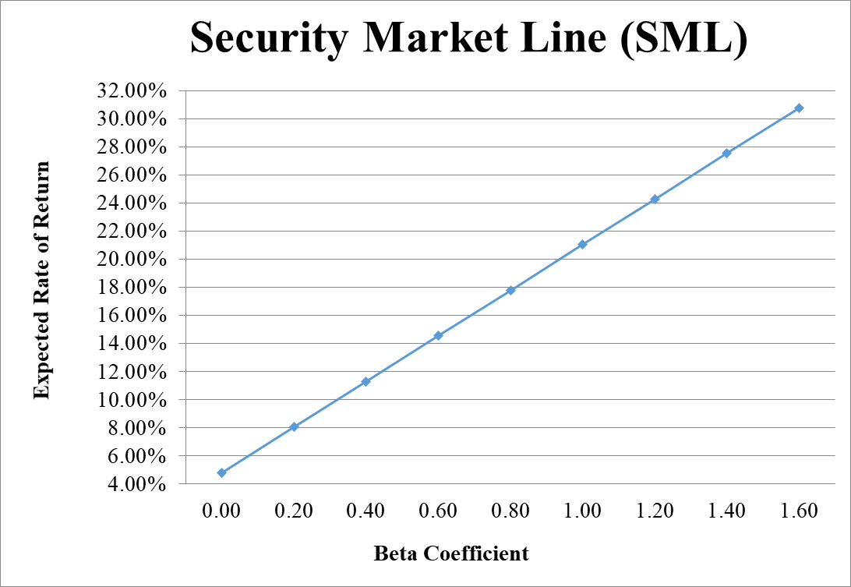
- From your plot in part c, which stocks appear to be your winners, and which ones appear to be losers? Explain the reason behind your conclusion. (2 Points)
- Logic → If Expected Return < SML Expected Return → Loser, otherwise Winner.
- Why should you consider your conclusion in part d) to be less than certain? (1 Point)
This conclusion is based on our having the right betas. Recall that calculation of Betas are subjective (i.e. depend on the market to be chosen, sample size, time interval chosen, definition of period…). If all of our betas understate their stock’s systematic risks, then we would be underestimating our portfolio risk.
GOOD LUCK!

